**Wireframe Document**

**Heart Disease Diagnostic Analysis**

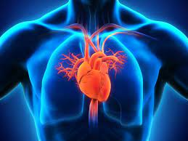

**Revision Number - 1.2**

**Last Date of Revision - 20/09/2022**

**Sikha Pandey**

# Document Control

|  |  |  |  |  |
| --- | --- | --- | --- | --- |
| **Date** |  | **Version** | **Description** | **Author** |
| 13/09/2022 | 1.0 |  | Introduction,  Problem Statement | Sikha Pandey |
| 16/09/2022 | 1.1 |  | Dataset Information,  Architecture  Description | Sikha Pandey |
| 20/09/2022 | 1.2 |  | Final Revision | Sikha Pandey |
|  |  |  |  |  |

**We Performed Exploratory Data Analysis on Jupyter Notebook and then created a Power BI Desktop Dashboard.**

1. **Number of the population suffering from Heart Disease?**

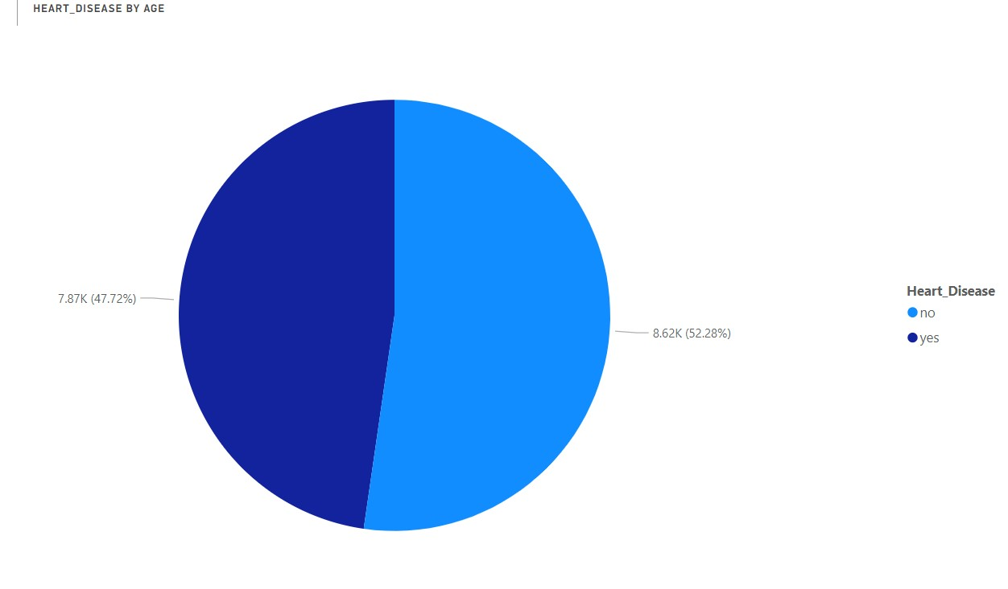

* According to the distribution 47.72% of people are suffering from Heart Disease

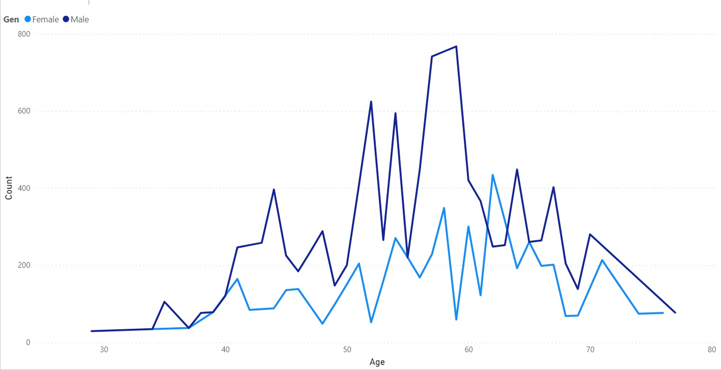

* Elderly males and females are more likely to suffer from heart disease. Males are between 50 to 60 years and Females are between 55 to 65 years.

**2. Who Suffers from Heart Disease based on Gender?**

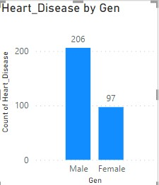

* Males are more prone to Heart Disease then females.

**3. Type of Chest Pain experienced?**

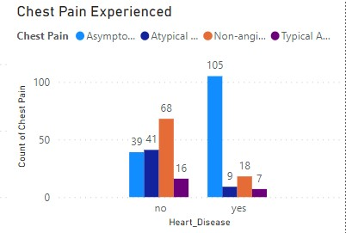

* Most people experienced the asymptomatic type of chest pain.
* It means it neither causes nor exhibiting symptoms of heart disease.

**3. What symptoms do people experience of heart disease?**

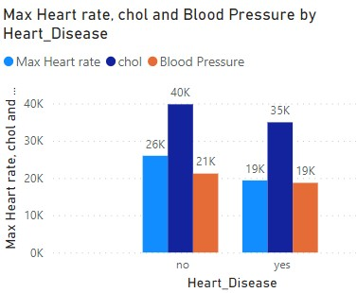

* **People having a high cholesterol levels are more likely to suffer.**

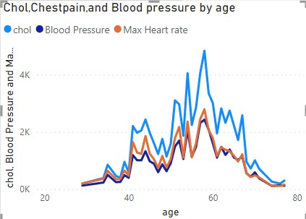

* Age group between 55-65 have high Cholesterol levels and are more likely to suffer from heart disease.
* Blood pressure also increases between the age of 50-60 which in turn can increase heart disease.
* People suffering from heart disease have high cholesterol, blood pressure, and chest pain.

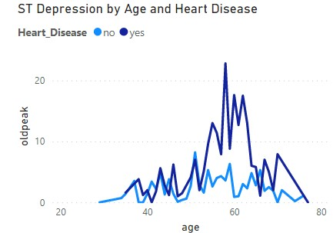

* We can observe from here that ST depression mostly increases between the age group of 30-40.
* ST depression refers to a finding on an electrocardiogram, wherein the trace in the ST segment is abnormally low below the baseline.